C h i l i C o o k – O f f

C o m p e t i t i o n

Saturday, October 12th – 6p-8p (event open 6p-9p)

Rules & General Information

1. To Enter, please contact Sabrina Shell at [sabrina.shell07@gmail.com](mailto:sabrina.shell07@gmail.com) and sign up on Track it Forward (if school family)
2. Chili must arrive by 5:15p at the designated area on the SFDS Field.
3. All Contestants must provide a full-size chafing dish (approximately 8 Quarts) full of hot chili on the evening of the event. Be prepared to keep your chili warm (Electrical will not be available. Please bring your own sterno cans, serving spoons, containers for any condiments, decorations, etc)
4. Be prepared to man your own table/serve your chili. You may decorate and have any other surprises to enhance your recipe and space. Table Space is 6’x2.5’. You will share the table with 2-3 other contestants.
5. The following items will be provided for the competition: Tasting cups, spoons and napkins. YOU are responsible for anything else.
6. 5 Service Hours will be given to Chili Chef

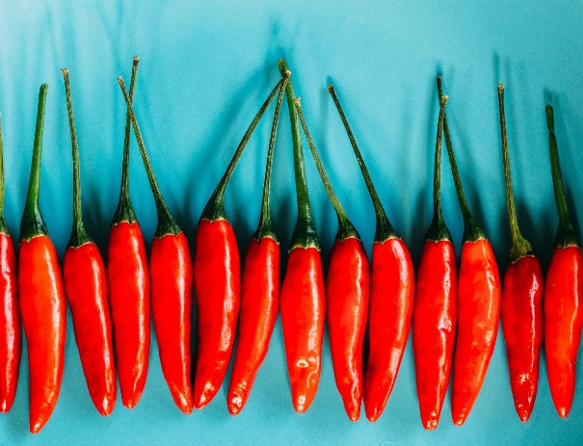

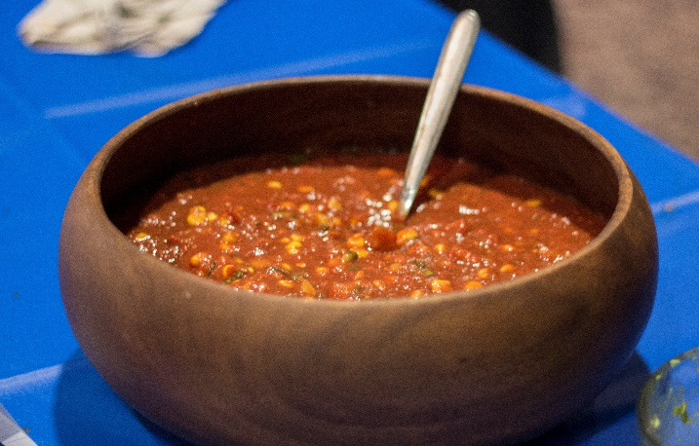

Proceeds from this event will benefit the SFDS Scholarship Fund